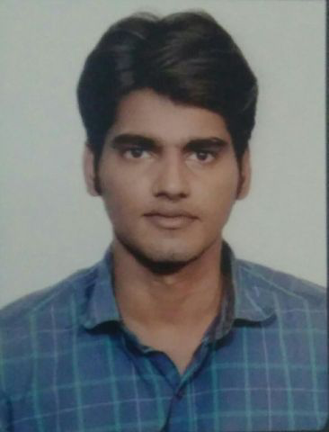

**Shubham Raj (Software Test Analyst )**

**Contact--+91 9999768341**

**EMAIL-shubhamraj529@gmail.com**

### Career Objective

Software Test Analyst, experienced in manual and automation testing looking for opportunity as a software test engineer to guide individual to gain knowledge in software testing field. .

**Highlights**

#### 4 + year of Software Testing experience in the field of Functional, Automation,Non-functional, API testing , testing of web-based applications.

* **Knowledge of programming language -JAVA ,**

#### Thoroughly reviewing the requirements analyzing and identifying scenarios that do and doesn't exist in the real time scenario's (technical and business).

#### Client handling experience, taking all call included as part of scrum

#### 4+ year working experience on Agile methodology

###### Technical Skills

**Domain Knowledge: , Banking, Capital Management**

**Testing Tools: ARD, JIRA, selenium, HP ALM, RTC**

**Database: MySQL**

**Testing Framework TESTNG**

**Framework - POM (Page object model)**

**Build Tool MAVEN**

**Programming skills- JAVA**

**Work Experience**

#### Accenture Pvt. Ltd. (October,2017 - Present)

Test Engineering Analyst - , UI testing, ARD inline Automation Analyzing Business Requirement Document (BRD) and Functional Design, Test Data Creation, Bug Reporting ,Database Testing and basic knowledge of automation testing

**Roles and Responsibilities**

* Test case Design,Test Execution, Bug Finding and Reporting and implementation of my automation knowledge to automate application
* Involved in meetings with client and providing ST Demos to business users and business analysts
* Performed Functional/Non-functional/Integration/Regression/UAT/Smoke testing
* Business Requirement Analysis according to change request

###### Work Experience

**ACCENTURE PVT LIMITED (OCT 2017-June-2021)**

###### Projects:

**Citi Bank -Customer Appointment Settings: -**

A digital platform for setting appointment between customer and banker. It was a web-based application in which customer has to provide their details to banker and this application will set appointment based on their need and available banker in that particular branch. There were many more functionality which were provided in this application for banker.

.

Team Size: 6

Client: Citi Group USA

Domain: Banking

Tools used: Soap UI, MySQL, ARD, UFT Web driver, HP ALM

Duration: December’17 –Jan 2019

**Avoka-Account Opening Application**

A web-based application used for the purpose of account opening of new and existing customer of CITI Bank

This application also involves testing of various downstream application which as based on mainframe technology

Team Size: 28

Client: Citi Group USA

Domain: Banking

Tools used: Soap UI, MySQL, ARD, Selenium Web driver, HP ALM, Testng,Maven

Duration: December’18 –June 2021

**MARLABS INC (Fortive group)-August 2021-March 2022)**

**VFA application-**This is capital management web-based application which is used for managing capital and investment planning in united states which focuses on managing budget and future capital forecasting

Team Size: 8

Client: Gordian group USA

Domain: Capital management

Tools used: MySQL, JIRA

Duration: December’18 –June 2021

Roles and Responsibilities:

* Going through newly added requirement and based on understanding preparing test plan for the release
* Pushing build received from dev team to the testing environment
* Providing reports to the product owner after completion of the testing
* Providing our testing input in all the agile related ceremonies

#### Educational Qualification

#### B.Tech 2017 MAIT, Delhi 72%

Senior Secondary Examination 2012 CBSE Board 78%

Secondary Examination 2010 ICSE Board 78%

###### Trainings and Internships

2 months of training program on Software Development and Testing at Accenture Pvt. Ltd., Gurugram from November’17 – December’17.

1 month of training program on Su-Kam products at Smart Solar Energy Centre, MAIT in June’16

###### Achievements and Commendations

Won ‘Star Performer of the Month’ award for reporting maximum number of valid defects.

Received rising star of CITI Group directly from client

Selected for TCS Remote Internship Program on the basis of All India Aptitude Test (2016).

**Personal Details**

Date of birth: Nov 11, 1995